Name: Suvikhyath Thirunahari
RollNo: 2503B05202
Stream: M-Tech (CSE-AIML)
Subject: Modern Operating System and computer Network
Assignment-3

Task:1

Problem -01:
A bit stream 1101011011 is transmitted using the standard CRC method. The generator polynomial is X4+X+1. What is the actual bit string transmitted?
CODE:
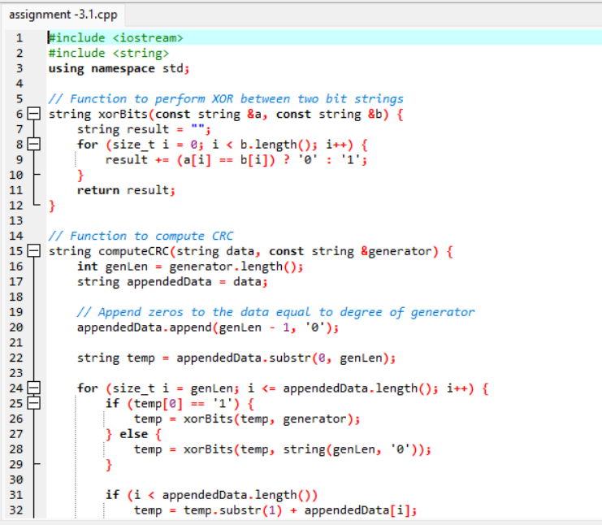
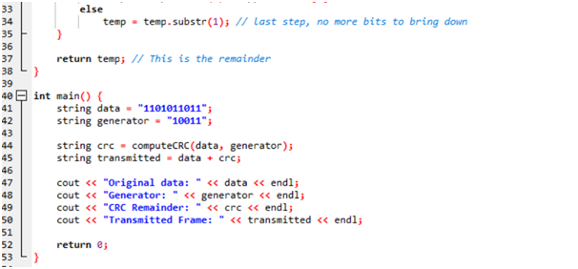

OUT PUT:
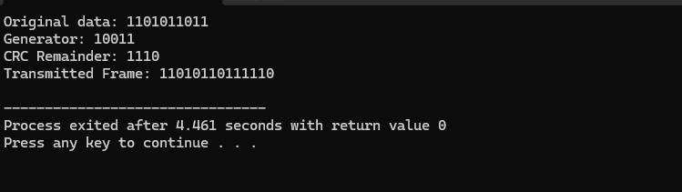

Task:2

Problem -02:
A bit stream 10011101 is transmitted using the standard CRC method. The generator polynomial is x³+1.
1.What is the actual bit string transmitted?
- Suppose the third bit from the left is inverted during transmission. How will receiver detect this error?

Code:
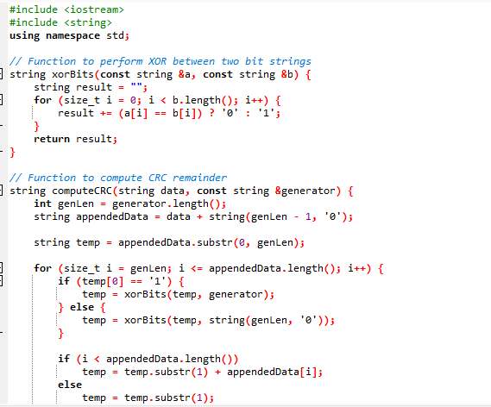
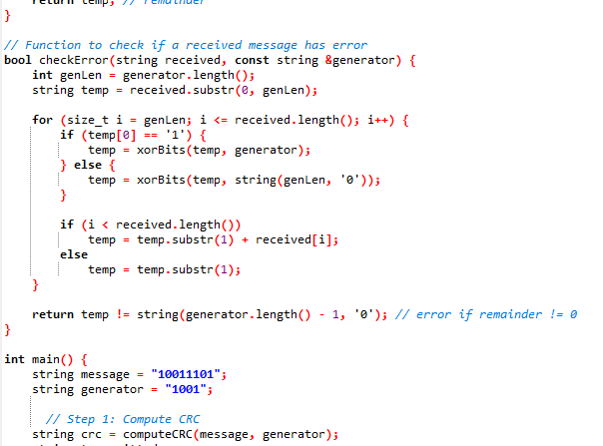
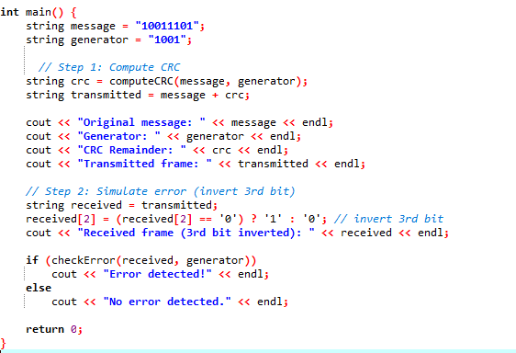

Output :
